**ECE321: COMMUNICATION SYSTEM LABORATORY**



**WTP -1 Report**

**AI-Powered Home Automation with Computer Vision**

Submitted to:

Dr. Charanjit Singh

Submitted by:

1. Shaik Mohammed Amzad 37 12207131
2. Vamsi Krishna Vyas 63 12205827

**Title:** AI-Powered Home Automation with Computer Vision

**Objective:**

The objective of this project is to develop an automated human presence detection system using Python-based image processing to detect human presence in a room. Upon detection, the system will wirelessly send a signal to an ESP32 microcontroller using the Wi-Fi protocol. The ESP32 will then control electrical appliances such as LEDs and a DC motor through a relay module, ensuring efficient energy management and automation.

This project aims to:

1. Detect human presence in a room using Python and AI based trained model for image processing.
2. Transmit the detection result wirelessly to an ESP32 microcontroller via Wi-Fi.
3. Control electrical appliances (LEDs and a DC motor) based on human presence detection.
4. Utilize a relay module to switch appliances ON/OFF efficiently.
5. Enhance energy efficiency by automatically turning off devices when no one is present.

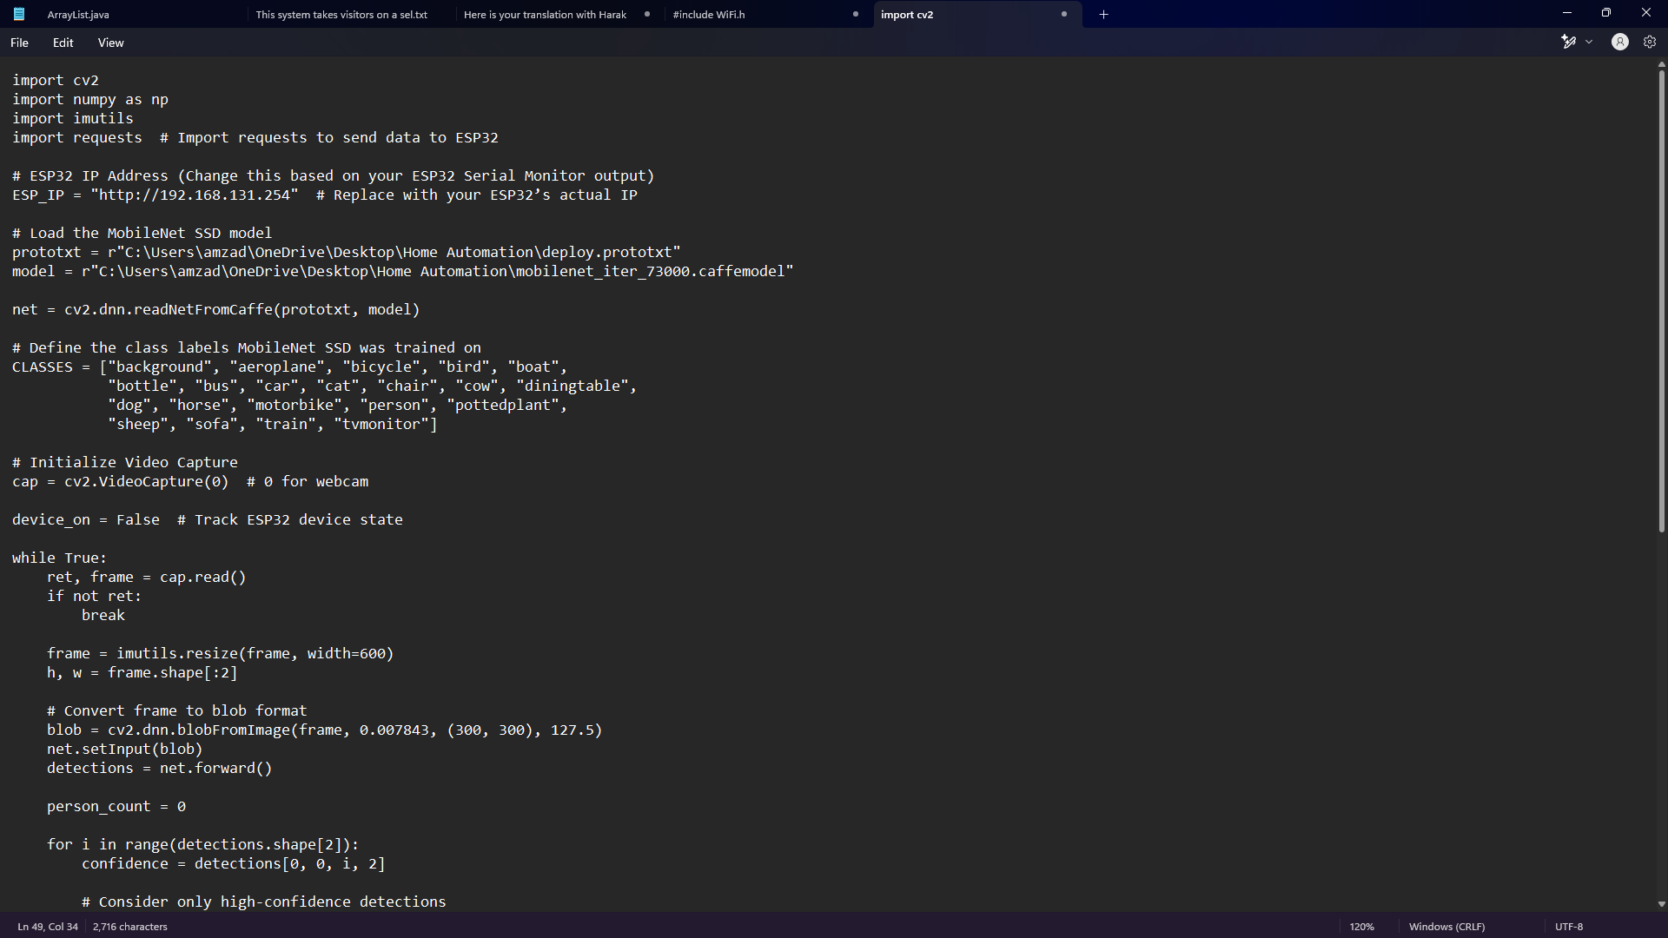**Python code:**

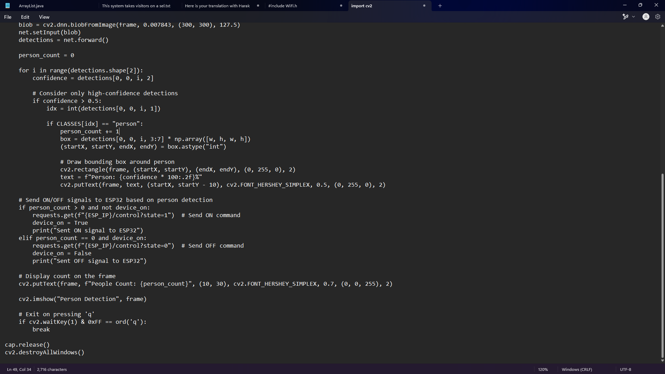

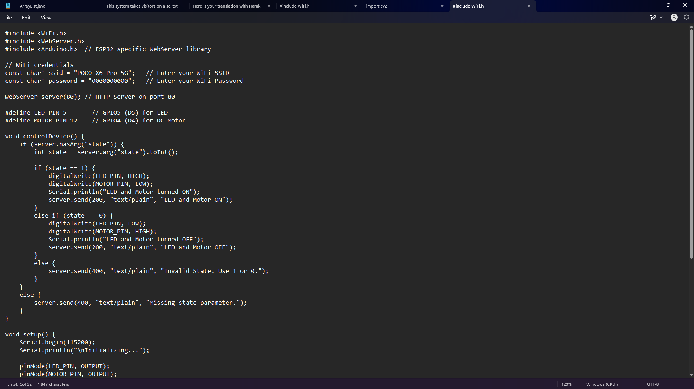**Esp32 Code:**



**Circuit diagram:**

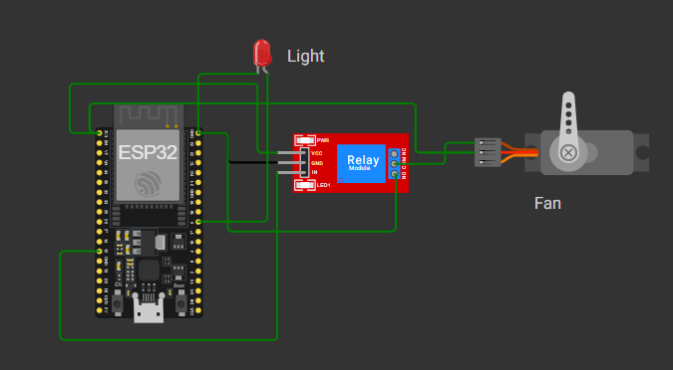

**Conclusion:**

The Human Presence Detection and Automated Appliance Control System successfully integrates computer vision and IoT to automate appliance control based on human presence. By leveraging Python and Trained AI Model for real-time detection and ESP32 with a relay module for device control, this project demonstrates an efficient method to reduce energy wastage and enhance automation.

The system ensures that appliances like LEDs and motors operate only when needed, leading to potential energy savings and improved efficiency. The use of Wi-Fi communication between the detection module and ESP32 enhances flexibility and allows remote control applications.

**Learning Outcomes:**

* Gained hands-on experience with ESP32 microcontroller and its integration with external devices using Wi-Fi communication.
* Learned how to use GPIO pins to control a relay module for switching appliances.
* Understood how to use Python and Trained AI Model for human presence detection in real-time video streams.
* Learned how a relay module works and how to control LEDs and motors using ESP32 GPIO outputs.
* Developed skills in hardware-software integration by linking Python-based detection with ESP32-controlled automation.
* Gained experience in troubleshooting issues like incorrect relay toggling, GPIO pin configurations, and power supply inconsistencies.
* Explored real-world applications of smart automation, energy-saving systems, and IoT-based smart homes.